CHAPTER 1
INTRODUCTION

1.1 INTRODUCTION TO COMPUTER GRAPHICS
Computer Graphics is concerned with all aspects of producing pictures or images using a computer.
Applications of Computer Graphics
- Display of information
- Design
- Simulation and animation
- User interfaces

The Graphics Architecture
Graphics Architecture can be made up of seven components:
- Display processors
- Pipeline architectures
- The graphics pipeline
- Vertex processing
- Clipping and primitive assembly
- Rasterization
- Fragment processing

Input
Devices
Mouse

Processor

Frame
Buffer

Memory

Output
Device
Figure 1.1: Components of Graphics Architecture and their working

1.2 INTRODUCTION TO OPENGL
OpenGL is software used to implement computer graphics. The structure of OpenGL is similar to that of most modern APIs including Java 3D and DirectX. OpenGL is easy to learn, compared with other.
APIs are nevertheless powerful. It supports the simple 2D and 3D programs. It also supports the advanced rendering techniques. OpenGL API explains following 3 components
- Graphics functions
- Graphics pipeline and state machines
- The OpenGL interfaces
There are so many polygon types in OpenGL like triangles, quadrilaterals, strips and fans.
There are 2 control functions, which will explain OpenGL through,
1. Interaction with window system
2. Aspect ratio and view ports

OpenGL
Application
Program

Frame
Buffer
GLU
Xlib, Xtk
GL
GLUT
GLX
Figure 1.2: OpenGL Library organization

Most implementations of OpenGL have a similar order of operations, a series of processing stages called the OpenGL rendering pipeline. This ordering, as shown in Figure 1.2, is not a strict rule of how OpenGL is implemented but provides a reliable guide for predicting what OpenGL will do. The following diagram shows the assembly line approach, which OpenGL takes to process data. Geometric data (vertices, lines, and polygons) follow the path through the row of boxes that includes evaluators and per-vertex operations, while pixel data (pixels, images, and bitmaps) are treated differently for part of the process. Both types of data undergo the same final steps (rasterization and per-fragment operations) before the final pixel data is written into the frame buffer.
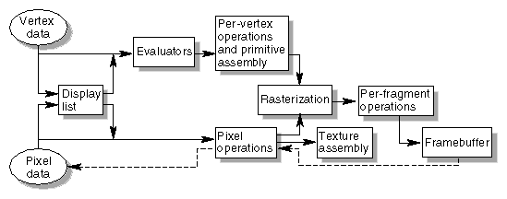

Figure 1.3: OpenGL Order of Operations
CHAPTER 2
REQUIREMENTS SPECIFICATION

2.1 SOFTWARE REQUIREMENTS
- Operating system – Windows XP or higher
- This project runs using Microsoft Visual Studio 2012
- OPENGL files which include GL, GLU, and GLUT
- Language used is C/C++

2.2 HARDWARE REQUIREMENTS
- Processor - Pentium Pro
- Memory - 128MB RAM
- 20GB Hard Disk Drive
- Mouse or other pointing device
- Keyboard
- Display device

CHAPTER 3
SYSTEM DEFINITION

3.1 PROJECT DESCRIPTION
A maze is a form of a complex branching passage through which the solver must find a route. In everyday speech, both maze and labyrinth denote a complex and confusing series of pathways, but technically the maze is distinguished from the labyrinth, as the labyrinth has a single through-route with twists and turns but without branches, and is not designed to be as difficult to navigate. The pathways and walls in a maze or labyrinth are fixed (pre-determined). The Cretan labyrinth is the oldest known maze.
Mazes have been built with walls and rooms, with corn stalks, hay bales, books, paving stones of contrasting colors or designs, bricks or in fields of crops such as corn or, indeed, maize. Maize mazes can be very large; they are usually only kept for one growing season, so they can be different every year, and are promoted as seasonal tourist attractions. Indoors, Mirror Mazes are another form of maze, where many of the apparent pathways are imaginary routes seen through multiple reflections in mirrors.
This project presents the maze game implemented using openGL in Visual C++. The user moves the object in the maze using the up, down, left, right direction keys. The ultimate goal of the user is to find the way through the maze to reach the destination, starting from the initial location. The user is provided with the facility to choose the desired level or to quit the game.
3.2 HOW TO PLAY THE GAME
Initially, we have three options. first is LEVEL 1, the second one is LEVEL 2 and the last option is QUIT. To move to the first level click on LEVEL 1 for the second level click on LEVEL 2 and to exit click on QUIT. When we click on LEVEL 1,the first level begins. We can direct the object towards the destination using the arrow keys (up, down ,right, left).Up key is for moving the object in upward direction, Down key is for moving the object in downward direction, right key is for moving the object in right direction and left key is for moving the object in left direction. The object is restricted to cross the walls and is confined to move only between them.
3.3 FLOWCHART

START
STOP
END OF INPUT
KEYspl()
MOUSEip()
false
Welcome screen()
Menu screen()

Rule screen()
Game screen()

MAZE

READING INPUT LEFT/RIGHT/UP/DOWN/MOUSE

Win()/ loose()

Display

Figure 3.1: Flow chart
3.4 ALGORITHM
Bresenham algorithm is been used in this to provide the functionalities it boasts of. It aims at implementing integer based calculations for determining the pixel co-ordinates. The algorithm is explained as follows:
- That pixel coordinates increase in the right and down directions (e.g. that the pixel at (1,1) is directly above the pixel at (1,2)), and
- That the pixel centers have integer coordinates.
The endpoints of the line are the pixels at (x₀, y₀) and (x₁, y₁), where the first coordinate of the pair is the column and the second is the row. The algorithm will be initially presented only for the octant in which the segment goes down and to the right (x₀≤x₁ and y₀≤y₁), and its horizontal projection x₁ − x₀ is longer than the vertical projection y₁ − y₀ (the line has a slope whose absolute value is less than 1 and greater than 0.) In this octant, for each column x between x₀ and x₁, there is exactly one row y (computed by the algorithm) containing a pixel of the line, while each row between y₀ and y₁ may contain multiple rasterized pixels.
Bresenham's algorithm chooses the integer y corresponding to the pixel center that is closest to the ideal (fractional) y for the same x; on successive columns y can remain the same or increase by 1.
The slope (y₁ − y₀) / (x₁ − x₀) depends on the endpoint coordinates only and can be precomputed, and the ideal y for successive integer values of x can be computed starting from y₀ and repeatedly adding the slope.
In practice, the algorithm can track, instead of possibly large y values, a small error value between −0.5 and 0.5: the vertical distance between the rounded and the exact y values for the current x. Each time x is increased, the error is increased by the slope; if it exceeds 0.5, the rasterization y is increased by 1 (the line continues on the next lower row of the raster) and the error is decremented by 1.0.
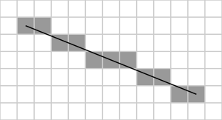
Figure 3.2: Bresenham’s Line Algorithm

  - USER DEFINED FUNCTIONS
- void build_row (int start, int end, int row): This function creates horizontal lines in the maze. Parameters: start indicates the initial position end indicates the final position row indicates the row number in which the line is to be drawn.
- void build_row (int start, int end, int col): This function creates vertical lines in the maze. Parameters: start indicates the initial position end indicates the final position col indicates the column number in which the line is to be drawn.
- void write(char *s,int size=0): This function writes the string on the screen.Parameter: s indicates the string size indicates the case;if size=0 then lower case and if size=1 then upper case.
- void startscreen(void): This function creates the start screen of the maze game which consists of LEVEL1, QUIT, LEVEL 2.
- void startgame(void): It redirects to the level chosen by the user.
- void draw(void): This function first checks the value in the array, if the value is 1 then it does nothing and if the value is 0 then it increments the coordinates of the object to move it and then calls the display function.
- void arrowkeys(int key,int x,int y): This function uses the direction keys (up, down, left, right) to move the object in the desired direction. It first checks the level of the maze and then increments or decrements the variables accordingly and then calls the draw ().

CHAPTER 4
IMPLEMENTATION

4.1 SOURCE CODE
#include <stdio.h>
#include<math.h>
#include<stdlib.h>
#include<GL/glut.h>
int xmin2=10,xmax2=20,ymin2=0,ymax2=10;
int xmin1=63,xmax1=88,ymin1=0,ymax1=25;
int h=0,f=0,lvl;
int a[500][500]={0};
int wh=750;
// to build the maze
void display1();
// initialize Options of game window
void myinit1()
{
glClearColor(0.0,0.0,0.0,1.0);
glMatrixMode(GL_PROJECTION);
glLoadIdentity();
gluOrtho2D(0.0,750.0,0.0,750.0); /
glMatrixMode(GL_MODELVIEW);
}
// initialize the game window
void myinit()
{
glClearColor(0.0,0.0,0.0,1.0);
glMatrixMode(GL_PROJECTION);
glLoadIdentity();
gluOrtho2D(-200.0,750.0,-200.0,750.0);
glMatrixMode(GL_MODELVIEW);
}
// Display characters
void write(char *s,int size=0)
{
while(*s!='\0')
{
if(size==1)
glutBitmapCharacter(GLUT_BITMAP_HELVETICA_18,*(s)++);

else
glutBitmapCharacter(GLUT_BITMAP_HELVETICA_12,*(s)++);

}
}
// Options of the game
void startscreen()
{
glColor3f(0.5,0,0);
glRectf(150,190,550,580);
glColor3f(0,0,1);
// specifies the raster position for pixel operation
glRasterPos2f(295,550);
// string to display
write("A",1);
glColor3f(1,1,0);
glRasterPos2f(310,550);
write("MAZE",1);
glColor3f(0,0,1);
glRasterPos2f(363,550);
write("ING",1);
glColor3f(0,0,0);
glRectf(250.0,450.0,450.0,500.0);
glColor3f(1.0,1.0,0.0);
glRasterPos2f(320.0,475.0);
write("LEVEL 1");
glColor3f(0,0,0);
glRectf(250.0,380.0,450.0,430.0);
glColor3f(1.0,1.0,0.0);
glRasterPos2f(330.0,405);
write("LEVEL 2");
glColor3f(0,0,0);
glRectf(250.0,300.0,450.0,350.0);
glColor3f(1,1,0);
glRasterPos2f(320.0,325);
write("QUIT");
glFlush();
}
// draw pointer
void draw1()
{
for(int i=xmin1+h;i<=xmax1+h;i++)
for(int j=ymin1+f;j<=ymax1+f;j++)
if(a[i][j]==1)
return ;
xmin1+=h;
xmax1+=h;
ymin1+=f;
ymax1+=f;
// marks current window as needing to redisplayed
glutPostRedisplay();
}
// draw pointer
void draw2()
{
for(int i=xmin2+h;i<=xmax2+h;i++)
for(int j=ymin2+f;j<=ymax2+f;j++)
if(a[i][j]==1)
return ;
xmin2+=h;
xmax2+=h;
ymin2+=f;
ymax2+=f;
glutPostRedisplay();
}
// keyboard functions
void arrowkeys (int key, int x, int y)
{
if(key == GLUT_KEY_RIGHT)
{
if (lvl==1)
{
h=15;f=0;
// draw pointer
draw1();
}
else
{
h=5;f=0;
draw2();
}
}
if(key == GLUT_KEY_DOWN)
{
if (lvl==1)
{
h=0,f=-15;
draw1();
}
else
{
h=0;f=-5;
draw2();
}
}
if(key == GLUT_KEY_LEFT)
{
if (lvl==1)
{
h=-15;f=0;
draw1();
}
else
{
h=-5;f=0;
draw2();
}
}
if(key == GLUT_KEY_UP)
{
if (lvl==1)
{
h=0;f=15;
draw1();
}
else
{
h=0;f=5;
draw2(); }
}
}
void reshape1(int w, int h)
{
glMatrixMode(GL_PROJECTION);
glLoadIdentity();
if(w<=h)
gluOrtho2D(-200.0,750.0,-200.0*(float)h/(float)w,750.0*(float)h/(float)w);

else
gluOrtho2D(-200.0*(float)w/(float)h,750.0*(float)w/(float)h,-200.0,750.0);
glMatrixMode(GL_MODELVIEW);
}
void startgame1()
{
glutInitDisplayMode(GLUT_DOUBLE|GLUT_RGB);
myinit();
glutReshapeFunc(reshape1);
// to build the maze
display1();
glutDisplayFunc(display1);
glutSpecialFunc(arrowkeys);
glutMainLoop();
}
// select options
void mymouse(int btn,int st,int x,int y)
{
// set the application callback for a mouse button event
if(btn==GLUT_LEFT_BUTTON&&st==GLUT_DOWN)
if(x<450&&x>250)
{
if((wh-y)>450&&(wh-y)<500)
{ lvl=1;
// start level 1
startgame1();
}
else if((wh-y)>380&&(wh-y)<430)
{
lvl=2;
// start level 2
startgame1();
}
else if((wh-y)>300&&(wh-y)<350)
exit(0);
}
}
// draw vertical lines
void build_row(int start, int end, int row)
{
glBegin(GL_LINES);
glVertex2f(start,row);
glVertex2f(end,row);
glEnd();
for(int i=start; i<=end; i++)
a[i][row]=1;
}
// draw horizontal lines
void build_col(int initial, int final, int col)
{
glBegin(GL_LINES);
glVertex2f(col,initial);
glVertex2f(col,final);
glEnd();
for(int i=initial; i<=final; i++)
a[col][i]=1;
}
// to build the maze
void display1()
{
glClear(GL_COLOR_BUFFER_BIT);
if(lvl==1)
{
// width of rasterized line
glLineWidth(10.0);
glColor3f(0.0,0.0,1.0);
// draw vertical line
build_row(0,50,0);
build_row(100,500,0);
build_row(200,350,50);
build_row(0,150,50);
build_row(450,500,50);
build_row(350,450,100);
build_row(150,200,100);
build_row(50,100,100);
build_row(100,250,150);
build_row(300,350,150);
build_row(450,500,150);
build_row(50,100,200);
build_row(150,200,200);
build_row(250,350,200);
build_row(0,50,250);
build_row(150,300,250);
build_row(400,450,250);
build_row(50,100,300);
build_row(200,250,300);
build_row(50,150,350);
build_row(250,300,350);
build_row(400,450,350);
build_row(250,350,400);
build_row(150,450,450);
build_row(100,500,500);
build_row(0,50,500);
glColor3f(1.0,1.0,0.0);
// draw horizontal lines
build_col(0,500,0);
build_col(100,200,50);
build_col(100,150,100);
build_col(300,450,50);
build_col(200,300,100);
build_col(400,500,100);
build_col(50,150,150);
build_col(200,300,150);
build_col(350,450,150);
build_col(100,150,200);
build_col(300,450,200);
build_col(50,200,250);
build_col(350,400,250);
build_col(50,100,300);
build_col(250,350,300);
build_col(100,150,350);
build_col(200,400,350);
build_col(0,250,400);
build_col(350,400,400);
build_col(150,200,450);
build_col(250,400,450);
build_col(0,500,500);
glColor3f(1,1,1);
// draw pointer
glRectf(xmin1,ymin1,xmax1,ymax1);
for(int i=ymin1;i<=ymax1;i++)
if(ymax1>500)
{
glColor3f(0.5,0,0);
glRasterPos2f(250.0,620.0) ;
write("YOU WON !!",1);
}
}
else if(lvl==2)
{
glColor3f(0.5,0.0,0.0);
glLineWidth(6.0);
// draw vertical line
build_row(0,150,25);
build_row(175,400,25);
build_row(425,500,25);
build_row(25,150,50);
build_row(175,325,50);
build_row(350,450,50);
build_row(25,150,75);
build_row(175,500,75);
build_row(25,175,100);
build_row(200,375,100);
build_row(400,500,100);
build_row(0,125,125);
build_row(150,225,125);
build_row(250,500,125);
build_row(0,150,150);
build_row(175,475,150);
build_row(0,50,175);
build_row(75,450,175);
build_row(0,425,200);
build_row(450,475,200);
build_row(25,150,225);
build_row(175,475,225);
build_row(25,500,250);
build_row(0,75,275);
build_row(100,475,275);
build_row(25,175,300);
build_row(175,475,300);
build_row(25,75,325);
build_row(100,300,325);
build_row(325,500,325);
build_row(0,175,350);
build_row(200,475,350);
build_row(0,400,375);
build_row(425,475,375);
build_row(0,125,400);
build_row(150,500,400);
build_row(0,25,425);
build_row(50,400,425);
build_row(425,500,425);
build_row(0,425,450);
build_row(450,500,450);
build_row(0,100,475);
build_row(125,500,475);
build_row(0,300,500);
build_row(25,500,0);
build_row(325,500,500);
glLineWidth(6.0);
// draw horizontal lines
build_col(25,50,25);
build_col(25,75,400);
build_col(50,75,150);
build_col(50,75,175);
build_col(75,100,25);
build_col(100,125,175);
build_col(100,125,200);
build_col(150,225,475);
build_col(150,175,150);
build_col(225,250,75);
build_col(225,250,175);
build_col(300,325,475);
build_col(300,325,250);
build_col(300,325,75);
build_col(325,350,200);
build_col(350,375,475);
build_col(400,425,400);
build_col(425,450,450);
build_col(475,500,400);
build_col(0,500,0);
build_col(0,500,500);
glColor3f(1.0,1.0,0.0);
glRectf(xmin2,ymin2,xmax2,ymax2);
for(int i=ymin2;i<=ymax2;i++)
if(ymax2>490 && (xmax2<325 && xmax2>315))
{
glColor3f(0,0,1);
glRasterPos2f(250.0,620.0);
write("YOU WON !!",1);
glRasterPos2f(250.0,550.0);
write("HURRAY !!",1);
}
}
glFlush();
glutSwapBuffers();
}
void dis()
{
glClear(GL_COLOR_BUFFER_BIT);
// Options of the game
startscreen();
glutMouseFunc(mymouse);
glFlush();
glutSwapBuffers();
}
void main()
{
printf("\n\n\n\n\n\n");
printf("\t GLOBAL ACADEMY OF TECHNOLOGY\n\n");
printf ("\tCOMPUTER SCIENCE AND ENGINEERING\n\n");
printf ("\tCOMPUTER GRAPHICS AND VISUALIZATION LAB(10CSL67) \n\n\n");
printf ("\t\t MAZE GAME\n\n\n");
printf ("\t\tPrashanth C(1GA14CS093) \n");
printf ("\t\tGUIDE: Mrs. Sowmya M\n");
printf ("\t\tAssistant Professor \n");
getchar ();
glutInitDisplayMode(GLUT_DOUBLE|GLUT_RGB);
glutInitWindowSize(750,750);
glutInitWindowPosition(0,0);
glutCreateWindow("maze");
myinit1();
glutDisplayFunc(dis);
glutMainLoop();
}

\

CHAPTER 5
TESTING AND RESULTS

5.1 DIFFERENT TYPES OF TESTING
1. Unit Testing
Individual components are tested to ensure that they operate correctly. Each component is tested independently, without other system components.
2. Module Testing
A module is a collection of dependent components such as an object class, an abstract data type or some looser collection of procedures and functions. A module related components, so can be tested without other system modules.
3. System Testing
This is concerned with finding errors that result from unanticipated interaction between sub-system interface problems.
4. Acceptance Testing
The system is tested with data supplied by the system customer rather than simulated test data.

5.2 SNAPSHOTS
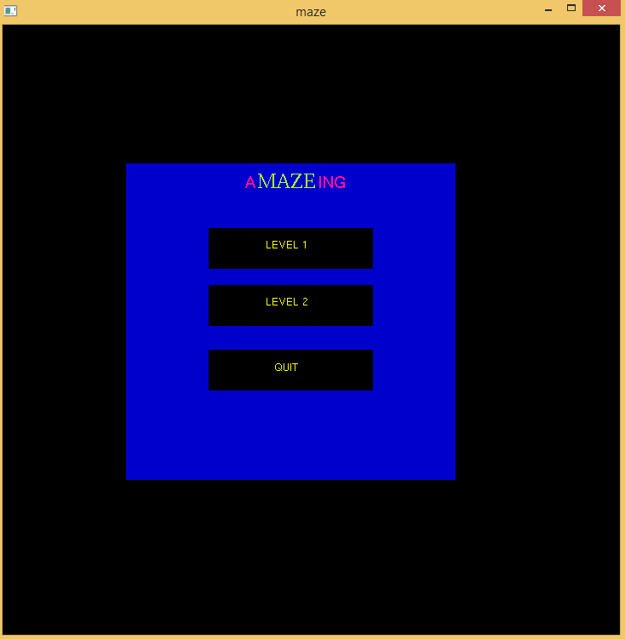
Snapshot 5.1: Start Screen

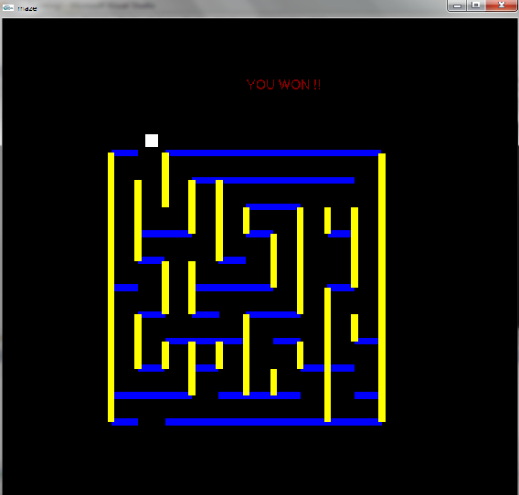

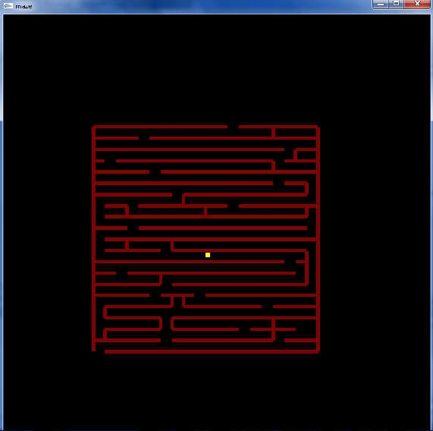
Snapshot 5.2: Level 1

Snapshot 5.3: Level 2

CONCLUSION

With modest aim and no prior experience in any programming projects as this, many concepts were made easily understandable. It helped in increasing programming skills and getting into the real world of software development.
This is a simple interactive application. It is extremely user friendly and has the features which makes simple graphics project. It has an open source code and no security features has been included.
The “MAZE GAME” project has been made in such a way that several changes can be done. The project is helpful in implementing theoretical knowledge. It gives a complete grasp on how the transformation works in OpenGL.

BIBLIOGRAPHY

Books
[1] Edward Angel: Interactive Computer Graphics: A Top-Down Approach Using OpenGL
[2] F.S. Hill Jr: Computer Graphics Using OpenGL,2nd Edition, Pearson
Websites
[1] http://www.glprogramming.com/red/chapter08.html
[2] http://pyopengl.sourceforge.net/documentation/manual/
[2] http://en.wikibooks.org/wiki/OpenGL_Programming/Modern_OpenGL_Introduction

